

**Code Implementation For Category | Belayneh Mathewos**

**Category**

**Coding Functionalities:**

**Introduction**

**Code**

**PHP Code:**

**Connector Class**

To declare and asign a necessary terms to access a database and to create a connection to a database server.

Open the *helpers.inc.php and connectDB.php* file.

**item_Class**

Which retrives the database items name and displays it on webpage. It includes a connector class to create a connection to the database.

Open the *post-form.html.php* file.

**With CSS Code**

**Front Page(a sample home page) to test my code**

Styling a page with css, and navigation link to the display page is done.

Open the *front_Page.php* file.

**Submit to database**

Submits all details of user products into database.

*Submit-to-DB.php file.*

For furtherly look at the files in a zip file Category.

**FrontPage**

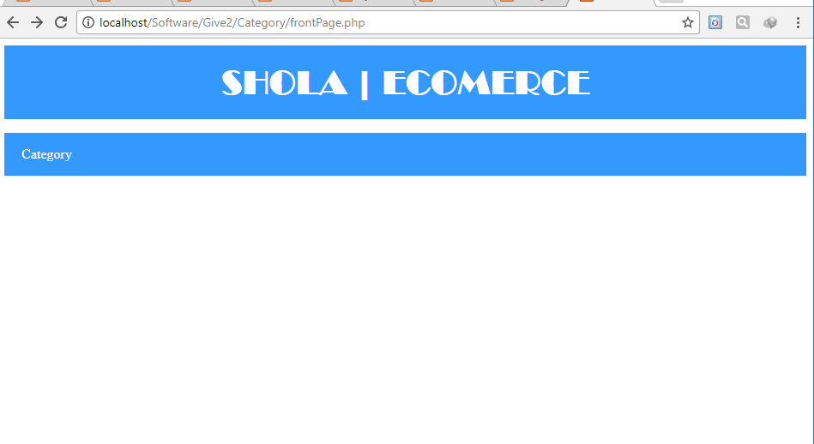

**displayItem**

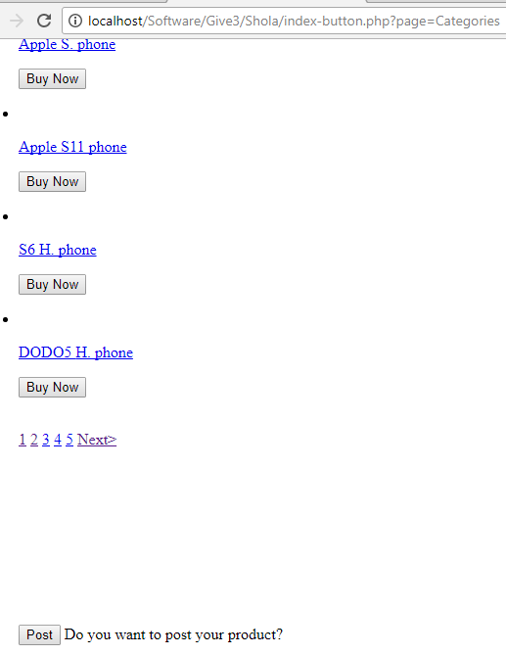

**Submit-to-database**

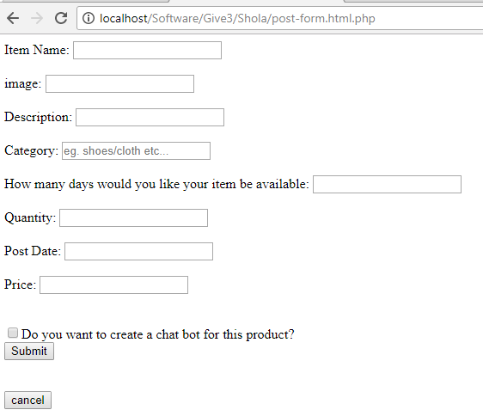

**database**